**Smart House Environment Control System**

**IOT Project**

Supervised by:

***DR/Ahmed Shalaby***

***ENG/Ghada***

**Problem Definition:**

Provide an automatic system to control home without needing to human interaction.

Some automatic operations like turn off or turn on fan, led on or off.

And close or open window according to temperature, humidity, and light intensity.

System send data to cloud and do processing and display in dashboard.

So, all process will be automatic and smart.

**Objectives**

Smart environment that sensor sense temperature and humidity and do some processing to detect state of fan and window if condition true it will turn on, off fan.

And shut down, up to window .and another sensor outside home to detect light intensity to save electricity by turn on, off led outside according to condition of light is it morning or night.

**Scope**

Include:

* Temperature and humidity sensor.
* Photoresistor to sense light intensity.
* Local server to store data in it.
* Sending data from Arduino IDE to python platform using MQTT
* Connect python to dashboard (html templates) using FLUSK.

Exclude:

* + Our system just only connected to led, window, fan.
  + Not related to other devices in house.
  + People who don’t authorized to access system does not have Permission to see data just only owners of the house.

**Proposed Solution:**

The home automatic environment that has access to Fan, Window, Led outside house.

If measured temperature <26 the FAN_STATE is off

Else FAN_STATE is on.

If measured humidity [40:60] WINDOW_STATE Closed

Else WINDOW_STATE is Open.

If measure light <800 LED_STATE is Off else LED_STATE

Is On.

And send data in dashboard with plot of recent measurements.

**System Input Output**

**Inputs**

1-tempreture, humidity and intensity of light.

**Output**

1-WINDOW_STATE, FAN_STATE and LED_STATE.

|  |  |
| --- | --- |
| Input /output | Description |
| Temperature | Entered using DHD11 to define fan state |
| Humidity | Entered using DHD11 to define window state |
| Light Intensity | Entered using photoresistor to define led state |
| Window state | output using Condition of humidity to define window (open-close) |
| Fan State | output using Condition of temperature to define fan (on-off) |
| Led State | output using Condition of photoresistor to define led state (on, off) |

**Device layer**

**Sensor**

**1-DHD11**

DHT11 Temperature & Humidity Sensor features a temperature & humidity sensor complex with a calibrated digital signal output. By using the exclusive digital-signal-acquisition technique and temperature & humidity sensing technology, it ensures high reliability and excellent long-term stability. This sensor includes a resistive-type humidity measurement component and an NTC temperature measurement component and connects to a high performance 8-bit microcontroller, offering excellent quality, fast.

**2-Photoresistor**

a semiconductor device that converts a light signal into a current signal

A photoresistor, also known as a light-dependent resistor (LDR) or photocell, is an electronic component whose resistance decreases as the intensity of light falling on it increases.

|  |  |
| --- | --- |
| **Sensor /Actuators** | **Description** |
| Photoresistor | Sense light intensity outside the home |
| DHD11 | Sense temperature and humidity |
| window | Open-close according to humidity function |
| Fan | On-off according to temperature function |
| led | On -off according to light intensity function |
| Humidity Function | If Measured Humidity [40:60] window state Closed.  Else window state Is Open. |
| Temperature function | If measured temperature <26 the fan state off  Else fan state is on. |
| Light intensity function | If measure light <800 led state is Off else led state  Is On. |

1. **Block Diagram**

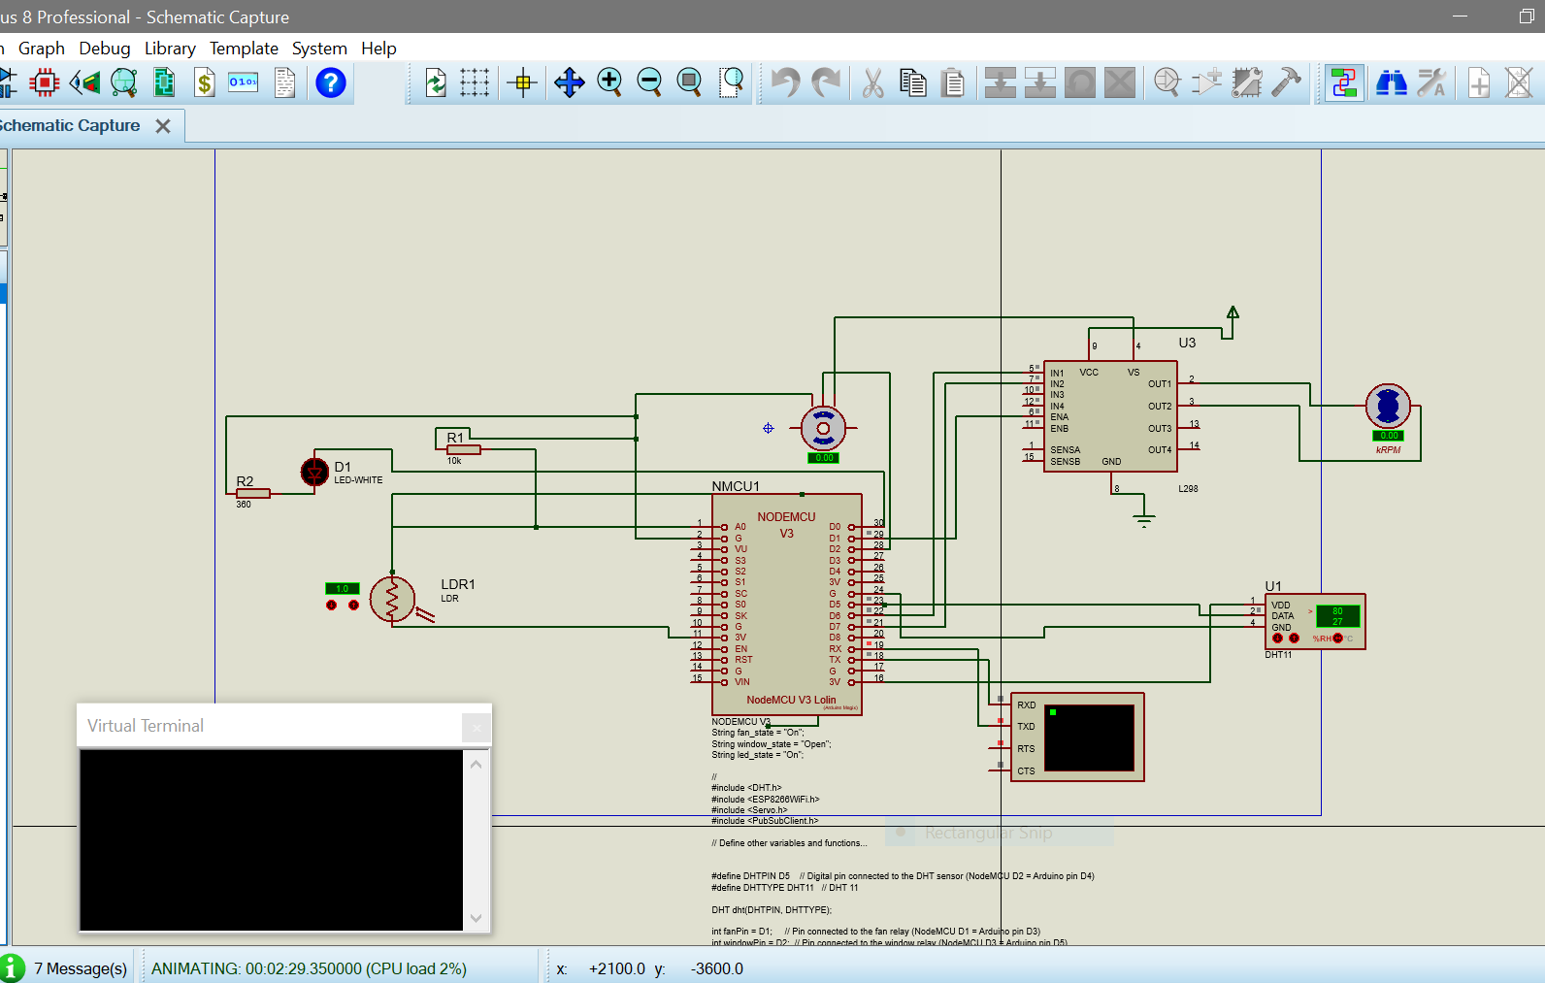

1. **Flow Chart**

1. **Finite State Machine**

1. **Test Cases**

|  |  |  |  |  |  |  |
| --- | --- | --- | --- | --- | --- | --- |
| Case | temp | humidity | Light intensity | led | fan | window |
| 1 | 31.5 | 39 | 1024 | off | on | open |
| 2 | 34 | 87.5 | 1024 | off | on | open |
| 3 | 32.5 | 59 | 1024 | off | on | closed |
| 4 | 32 | 38 | 507 | on | on | open |

2-test 2

Plot to data :

